High-Level Design (HLD) –

Entities –

1. Patient_Info
2. Doctor_Info
3. Clinic_Info
4. Appointment_Details
5. Time_Slot
6. Clinic_Doctor_Info

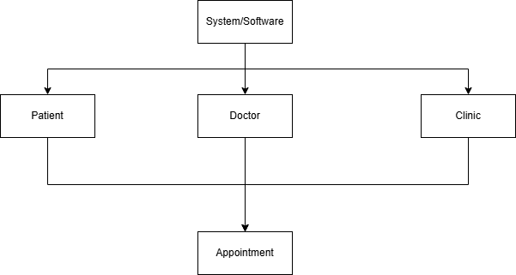

Low-Level Design (L LD) –

1. Patient_Info

|  |  |  |
| --- | --- | --- |
| **Field Name** | **Type** | Description |
| patient_id | INTEGER (Primary Key) | Unique Patient Id |
| patient_name | VARCHAR (N) | Patient Name of N length |
| patient_contact | VARCHAR (N) | Patient Contact Information of length N |

1. Doctor_Info

|  |  |  |
| --- | --- | --- |
| **Field Name** | **Type** | Description |
| doctor_id | INTEGER (Primary Key) | Unique Doctor Id |
| doctor_name | VARCHAR (N) | Doctor Name of N length |
| doctor_speciality | VARCHAR (N) | Doctor Specialization of length N |

1. Clinic_Info

|  |  |  |
| --- | --- | --- |
| **Field Name** | **Type** | Description |
| clinic_id | INTEGER (Primary Key) | Unique Clinic Id |
| clinic_name | VARCHAR (N) | Clinic name of N length |
| clinic_location | VARCHAR (N) | Clinic location/address of length N |

1. Time_Slot

|  |  |  |
| --- | --- | --- |
| **Field Name** | **Type** | Description |
| time_id | INTEGER (Primary Key) | Unique Time Id |
| start_time | DATETIME | Appointment Start Time |
| end_time | DATETIME | Appointment End Time |

1. Clinic_Doctor_Info

|  |  |  |
| --- | --- | --- |
| **Field Name** | **Type** | Description |
| ID | INTEGER (Primary Key) | Unique Id |
| doctor_id | INTEGER (Foreign Key) | Foreign Key to Doctor_Info |
| clinic_id | INTEGER (Foreign Key) | Foreign Key to Clinic Info |

1. Appointment_Details

|  |  |  |
| --- | --- | --- |
| **Field Name** | **Type** | Description |
| appointment_id | INTEGER (Primary Key) | Unique Appointment Id |
| appointment_date | DATETIME | Appointment Date and Time |
| appointment_status | VARCHAR (N) | Appointment Status (Completed/Incomplete/Reschedule/etc…) |
| patient_id | INTEGER (Foreign Key) | Foreign Key to Patient Info |
| clinic_id | INTEGER (Foreign Key) | Foreign Key to Clinic Info |
| doctor_id | INTEGER (Foreign Key) | Foreign Key to Doctor Info |
| time_id | INTEGER (Foreign Key) | Foreign Key to Time Info |

